My name is Angela Crotsenberg, and I am the Residency Coordinator for the PGY-1 Pharmacy Residency Program at Cheyenne Regional Medical Center (CRMC) in Cheyenne, Wyoming. I am e-mailing you today in hopes of reaching your pharmacy students at University of the Pacific Thomas J. Long School of Pharmacy with information about our residency program. In recent years it has been more difficult for pharmacy students to learn about residency programs in smaller hospitals, especially those that may not be located in their geographical region. CRMC’s PGY-1 residency is a robust program that will prepare new pharmacists for a PGY-2 pharmacy residency or pharmacy practice in hospital or ambulatory care settings.
More information on our program can be found on our residency website at https://www.cheyenneregional.org/careers/pharmacy-residency-program. We are encouraging interested students to reach out to me with any questions. The residency application deadline for our program is Tuesday, January 3, 2022.
In addition, we are hosting a virtual open house on Friday, December 16 from 1:00 to 4:00 MST.
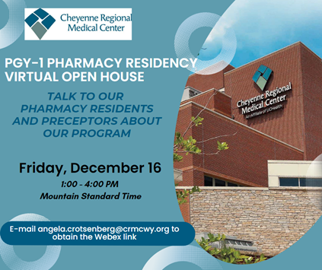
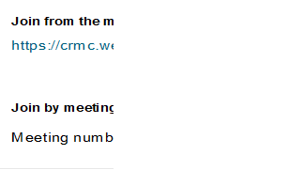

Thank you so much for your assistance in distributing this information to your pharmacy students. I can be contacted by phone at 307-996-1518 or by e-mail at angela.crotsenberg@crmcwy.org.

Kind regards,

Angi Crotsenberg, PharmD, BCPS
Pharmacy Instructor and Residency Coordinator
Cheyenne Regional Medical Center
307-996-1518
angela.crotsenberg@crmcwy.org

